

NATIONAL UNIVERSITY OF SINGAPORE
INVENTION DISCLOSURE FORM

INSTRUCTIONS
- Filling Out the Correct Forms
- If this is a software-based invention, complete instead a Software Invention Disclosure form.
- If this invention has a hardware component and a software component, then complete first this Invention Disclosure Form and questions 22-29 only in the Software Invention Disclosure form.
- If this is a reagent, complete instead a Reagent Invention Disclosure form.
- For all other intellectual property or inventions (hereinafter “invention”), please complete this Invention Disclosure Form

- Things to Note
- This Invention Disclosure Form serves as an official notification to NUS via its Industry Liaison Office (“ILO”) about the conception of any invention. Upon reception of the completed Invention Disclosure Form, ILO will conduct an evaluation of the invention disclosed and decide on the best course of action to commercialise this invention, which may, or may not include, filing a provisional patent application.
- Any public disclosure of the invention prior to submission of this Invention Disclosure Form will jeopardise any potential application for patent protection. Submit this Invention Disclosure Form well in advance of a submission containing information on the invention to a conference or journal. Bear in mind the standard evaluation period of an Invention Disclosure is 90 days.
- Only list as an inventor any individual who has conceived or contributed an essential element of the invention, either independently or jointly with others, during the evolution of the technology conception or reduction to practice (i.e., development of the invention).

- Additional documents you will need to complete this form
- Download Appendix 1 to understand what constitutes Public Disclosure at http://bit.ly/1rrVdUN.
- Download Appendix 2 for more information on what constitutes Novelty & Unobviousness at http://bit.ly/1oYrbnJ.
- Download Appendix 3 - TRL for HW and PMLH to assess the TRL of this invention at http://bit.ly/1w7o06I.

- To Do
- Submit the following two documents to ilobox3@nus.edu.sg and cc your Head of Department and Dean for their information:
- One MS Word version of this invention disclosure.
- One PDF version of this invention disclosure fully signed by all NUS and non-NUS inventors.

- If in doubt about any information requested by this form, please contact: ilobox3@nus.edu.sg

For ILO use only.
ID:
1. Title of the Invention (What is it? Be clear and concise): Write here…

I. GRANTS AND CONTRACTUAL OBLIGATIONS
Funding Agencies:  - A*STAR  - CERP (NRP)  - CRP (NRF)  - DSTA  - DSO  - EIRP (NRF) | - GAMBIT  - HEBREW  - MDA  - MOE Tier 1  - MOE Tier 2  - MOE Tier 3  - NEA ETRP | - NMRC  - POC (NRF)  - SEC  - SJTU  - SMa  - SMART  - Thermofisher  - Other Agency
2. Grant  - Funding source (from above):  MOE Tier 3 Grant  - If “Other Agency”, please specify:  - Grant Number:  T3-1-009  - Project title:  Random Numbers from Quantum Processes | 2.1 Additional source of Funding 1  - Funding source (from above):  N/A  - If “Other Agency”, please specify:  …  - Grant Number:  …  - Project title:  … | 2.2 Additional source of Funding 2  - Funding source (from above)  N/A  - If “Other Agency”, please specify:  …  - Grant Number:  …  - Project title:  …
3. If the invention is the result of a signed research agreement, indicate:
- Title: N / A
- ILO Reference Number: N/A
- Collaborator(s)’ organisation(s): N/A

II. PUBLIC DISCLOSURE
4. Has this invention been publicly disclosed? If so, indicate when and where was this invention disclosed: | No
5. If the invention has not been publicly disclosed, indicate when and where will it be disclosed, if at all: | Not later than 31 March 2015

III-A. NUS INVENTORS
Each undersigned Inventor acknowledges and agrees that if this Form is transmitted by facsimile transmission or other electronic means in portable document format (“pdf”) to National University of Singapore which results in transmission of a facsimile of his signature as an inventor making the disclosures of the invention disclosed in the Form, such facsimile or other electronically-transmitted Form shall be for all purposes effective as if such inventor had delivered the original of this Form and the facsimile or electronic signature of the inventor shall be deemed to be his original signature for all purposes.
We/I hereby fully consent to NUS collecting, using and/or disclosing my/our personal data in any form and to disclose the same to third parties (including any third party located outside of Singapore) for the purpose of the registration, protection and management of the invention disclosed hereunder in compliance with the Singapore PDPA 2012. I represent and warrant that the personal data I have provided to NUS in this Form are true and accurate and that I am the user and/or subscriber of the telephone number submitted in this form.
I/We, (an) inventor(s) who is(are) employees of NUS, hereby declare to the best of my/our knowledge the information provided in this Form are true and correct. I/We hereby agree to assign all rights, title and interest to this invention to NUS and/or such third parties under the Grant or relevant contracting parties to the relevant research agreement giving rise to the invention, as the case may be, and agree to execute all documents as requested, assigning to NUS, and/or such third parties, our respective rights to this invention and in any patent application filed on this invention, and to cooperate with the NUS Industry Liaison Office (“ILO”) in the protection of this invention. NUS will share any income derived from the invention with the inventor(s) who are NUS employees according to its I.P. Policy, as may be updated from time to time.
 | Inventor 1 | Inventor 2 | Inventor 3 | Inventor 4 | Inventor 5
6. Family Name  (as it appears in official document or passport) | Shi | Chng | Kurtsiefer
7. Given Name  (as it appears in official document or passport) | Yicheng | Mei Yuen, Brenda | Christian
8. Citizenship |  |  | German
9. Staff or Student No. |  |  | 022451
10. Faculty & Department  (to which this invention should be attributed to) | CQT | CQT | CQT
11. Contact Phone |  |  | 65161250
12. Email  (NUS and Personal account) |  |  | phyck@nus.edu.sg
13. Mailing Address |  |  | Centre for Quantum Technologies,  NUS  3 Science Drive 2  117543 Singapore
14. Intellectual Contribution/Income Split
15. Signature

III-B. NON-NUS INVENTORS
Each undersigned Inventor acknowledges and agrees that if this Form is transmitted by facsimile transmission or other electronic means in portable document format (“pdf”) to National University of Singapore which results in transmission of a facsimile of his signature as an inventor making the disclosures of the invention disclosed in the Form, such facsimile or other electronically-transmitted Form shall be for all purposes effective as if such inventor had delivered the original of this Form and the facsimile or electronic signature of the inventor shall be deemed to be his original signature for all purposes.
We/I hereby fully consent to NUS collecting, using and/or disclosing my/our personal data in any form and to disclose the same to third parties (including any third party located outside of Singapore) for the purpose of the registration, protection and management of the invention disclosed hereunder in compliance with the Singapore PDPA 2012. I represent and warrant that the personal data I have provided to NUS in this form are true and accurate and that I am the user and/or subscriber of the telephone number submitted in this form.
I/We, (an) inventor(s) who is(are) not (an) NUS employee(s), hereby declare to the best of my/our knowledge the information provided in this Form are true and correct. I/We hereby agree to assign all rights, title and interest to this invention to NUS and/or such third parties under the Grant or relevant contracting parties to the relevant research agreement giving rise to the invention, as the case may be, and agree to execute all documents as requested, assigning to NUS and/or such third parties, our respective rights to this invention and in any patent application filed on this invention, and to cooperate with the NUS Industry Liaison Office (“ILO”) in the protection of this invention. NUS will share any income derived from the invention with such third parties or contracting parties in accordance with the terms of the relevant Grant or research.
 | Inventor 1 | Inventor 2 | Inventor 3 | Inventor 4 | Inventor 5
6. Family Name
(as it appears in official document or passport)
7. Given Name
(as it appears in official document or passport)
8. Citizenship
9. Organization
10. Contact Phone
11. Contact Address
12. Email
(Organisation’s and Personal account)
13. Mailing Address
14. Intellectual Contribution/Income Split
15. Signature

IV. DETAILS OF THE INVENTION
16. Overview – Provide a summary or general description of the invention including its field of application:
Random number generators based on measurements based on noisy physical processes involve a physical process, a measurement step, and a “cleanup” stage to remove any residual bias or correlations in the measurements that originate from either the measurement process or the initial physical noise process. Such physical random number generators are superior to random number generators based on algorithms because they are intrinsically non-deterministic. This is an important aspect for cryptographic and other communication applications (authentication), or even for applications like gambling where random numbers need to be non-predictable. The cleanup process is referred to as a randomness extractor, and is often the bottleneck for preparing random numbers from physical measurements. Typically, this is done with cryptographic hash functions, or methods that are similar to encryption techniques. Applications in computer systems that generate random numbers from entropy collected from environmental events also use such methods (“Whirlpool”).
In this disclosure, we describe a method for removing bias and residual correlations (randomness extractor) derived from measurements on noisy physical systems based on a Linear Feedback Shift Register (LFSR). This leads to a significant simplification of the randomness extraction in comparison with the hashing or cryptographic encoders. The simplification is in the local memory, number of steps and logical operations. Therefore, this method can help either in the generation of random numbers with a very high bandwidth based on physical processes, or in situations where very limited resources are available, e.g. in mobile devices, or for on-chip random number generators where power consumption and silicon real estate is an issue.
The proposed method is efficient in the sense that it is able to extract random numbers up to the content of entropy in the underlying physical measurement.
Random numbers extracted from physical sources pass all the typical tests (NIST suite, die-harder test) for randomness on a relatively large set of random numbers.
17. Novelty & Unobviousness – List the features of this invention that make it a substantial and significant improvement, or the case of new and unexpected results, over existing technology (i.e., methods, devices and/or materials). Indicate what are the unique benefits or advantages these features provide.
Feature |  | Benefit/Advantage
The proposed method is extremely lean in resource requirements (storage elements, logical operations). Specifically: |  | Existing randomness extractors based on SHA hashes or cryptographic methods like AES involve a significant number of logical connections, clock cycles and local memory that often is the bottleneck for extracting randomness in constrained environments.
Low complexity in terms of memory and logical operations |  | Randomness extractors can be integrated into embedded systems
Low complexity in terms of clock steps |  | High quality random numbers (i.e., no bias, no correlations) can be generated at very high speeds
Low power consumption per random bit |  | The low complexity allows for physical randomness extraction from physical sources in situations with extremely limited power, like mobile communication units and even smart cards
18. Limitations – Describe the limitations, if any, of this invention in terms of, for instance, scalability, speed, power consumption, efficiency, use of exotic compounds, etc.
Some preliminary tests show that the length of the LFSR will effect the extraction performance. For extractors consutructed with long LFSRs(128bits), the output random numbers pass the test suite. However, when shorter ones are used(< 64bits), failures start to appear in the test results. When using LFSRs shorter than 22bits, certain tests are failed with almost 100% probability. Our suspection is that the construct still relies on the complexity of LFSR to some extend, and in such case we recommend using longer LFSRs if possible.
19. Prior Art – List any other existing technologies or literature that more closely resemble the features and/or functionalities of this invention. Indicate how this invention differentiates from existing technologies or literature listed.
Existing random number generators based on physical sources of randomness with a bias or local correlations [1,3,5] use hashing algorithms, for example AES-128 [2], SHA-512 [4], or Whirlpool [6]. LFSR-generated sequences are in widespread use for spread spectrum generation in communication scenarios. It was also identified as a source to populate the matrix entries for Topeliz hashing in [7], that can be used to remove the bias. The method described in this disclosure is more efficient since we directly utilize the LFSR thus requiring less memory registers and computing cycles.
[1] Symul, T. and Assad, S. M. and Lam, P. K. “Real time demonstration of high bitrate quantum random number generation with coherent laser light” Applied Physics Letters, 23, 98, 2011
[2] National Institute of Standards and Technology. Specification for the Advanced Encryption Standard (AES).
[3] Gabriel, C. and Wittmann, C. and Sych, D. and Dong, R. and Mauerer, W. and Andersen, U. L. and Marquardt, C. and Leuchs, G. “A generator for unique quantum random numbers based on vacuum states” Nature Photon, 10 (4), 711-715, Aug 2010
[4] National Institute of Standards and Technology. Secure Hash Standard (SHS).
[5] Abellán, C. and Amaya, W. and Jofre, M. and Curty, M. and Acín, A. and Capmany, J. and Pruneri, V. and Mitchell, M. W. “Ultra-fast quantum randomness generation by accelerated phase diffusion in a pulsed laser diode” Optics Express, 2 (22), 1645, 2014
[6] William Stallings. The whirlpool secure hash function. 30(1):5567, Jan 2006. 4 Cryptologia,
[7] Krawczyk, Hugo “LFSR-based Hashing and Authentication” in Y.G Desmedt (ed.) “Advances in Cryptology – CRYPTO '94 LNCS 839” pp. 129-139, Springer-Verlag Berlin Heidelberg 1994
20. Commercial Applications – List the critical commercial problems this invention solves:
This method could not only be part of physical random number generators with a very high bandwidth, but also help to simplify the randomness pools that are kept within standard computers (e.g. the /dev/urandom mechanism in unix-type operating systems), or even mobile applications. Especially the latter would significantly benefit from the low use of resources of the method we developed. Another application would be in the verification stage of keys stored in smart cards, where physical random number generators can significantly complicate the reverse-engineering of stored keys from traffic analysis.
21. Commercial Interest – Provide details of the commercial parties that may be interested in this technology:
Company | Contact Person |  | Email
ST electronics Singapore (secure communication devices) | KAN Pak Leng, ST Electronics |  | kanpl@stee.stengg.com
Idquantique, Geneva, Switzerland (quantum random number generators) | Grégoire Ribordy |  | gregoire.ribordy@idquantique.com
Google (cell phone technology IP) | (unknown) |  | (unknown)
(CQT spinoff) | (TBD) |  | (TBD)
22. Plans – List your plans regarding this invention (e.g., indicate whether someone is currently working on this invention and to what end, if additional research funds are being applied for, etc.).
We are currently implementing random number generators based on quantum measurement processes, and use this invention to remove the bias from them. The results presented in the disclosure are obtained from prototypes of such generators that include the physical randomness source and the measurement setup as well. The devices are connected to a host machine via a USB port. We currently are working to implement the method described in this disclosure in a CPLD/FPGA that is part of the acquisition hardware. This invention is part of a research project on random numbers from quantum processes, and we intend to deliver a working prototype of such a device that limits the bandwidth of a USB2.0 interface, i.e., 400-480MBit/seconds after bias removal as part of this reseach proposal.
Another option for commerical exploitation would be to finalize the design that integrates the physical random number generator with the randomness extractor, and market it in spin-off company of CQT.
23. Technology Readiness Level – What is the overall Technology Readiness Level (TRL) of this invention?: 5
24. Material – If the invention uses material from another lab, company, or was purchased list the following, if applicable:
Material | Source |  | Material Transfer Agreement
N/A
25. Technical Description – Describe the technical details of this invention. You may include figures in this section. This section roughly corresponds to sections Methodology, Results, Analysis and Conclusions in a scientific paper:
LFSR based extractor for random number processing
Physical random number generators (RNG) usually output numbers that are biased and possess correlations between consecutive numbers, and are not directly suitable for most cryptographic purposes. A randomness extractor converts raw random numbers from such a RNG and outputs a number stream that is uncorrelated and bias free.
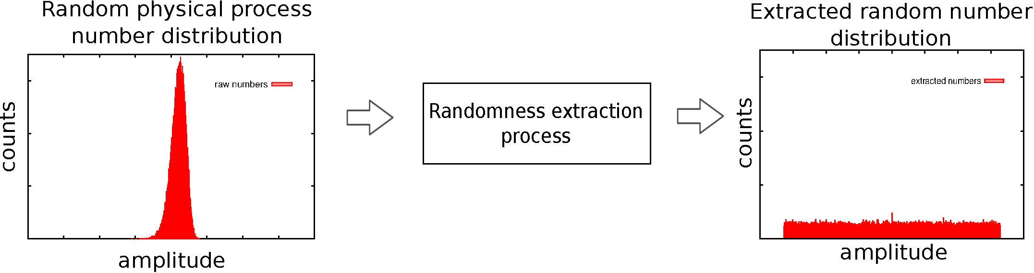
Fig 1. Randomness extraction process. For example, a physical random number generator generates a stream of numbers with a Gaussian distribution (left). The input stream is processed by the extractor to produce an output stream that follows a uniform distribution (right).
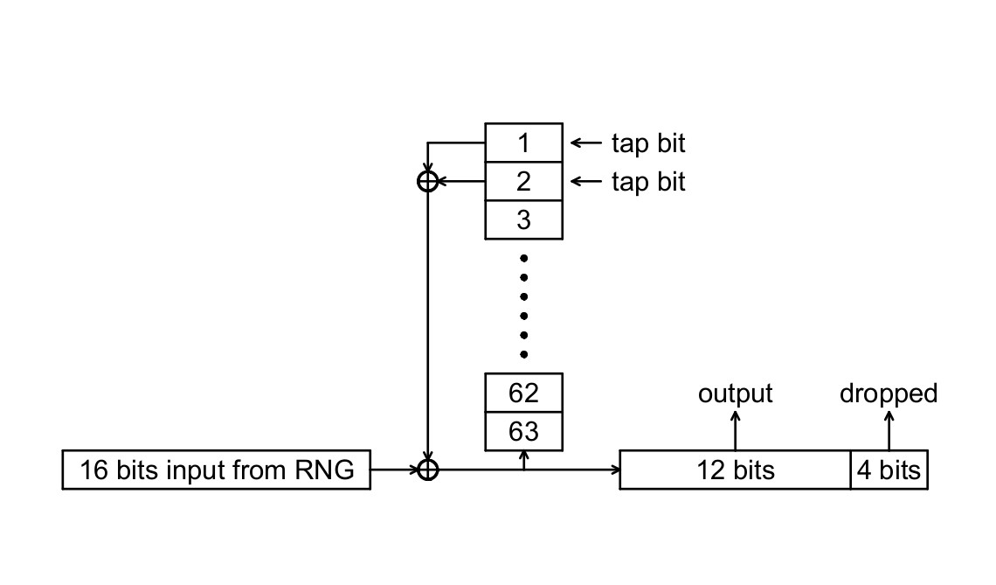
A typical implementation of a randomness extractor uses a cryptographic hashing function. Such hashing functions are proven to be effective and secure, but the complexity of the hashing functions slows down the processing speed and increases the implementation difficulty. We propose here a new randomness extractor based on a Linear Feedback Shift Register (LFSR). LFSR- type constructs are e.g. used for generating white noise in spread spectrum communication scenarios as their spectrum is uniform, the it is unbiased and easy to generate. The main idea is to use the uniformizing property of a LFSR-type mechanism, but additionally seed it with a binary sequence originating from a physical random source. We first introduce a serial version of this extractor for its simplicity, and later expand upon it to a parallel version that is able to process all the bits in the word provided by the measurement in a single clock step.
Serial Extractor
Fig 2. Example of a 63-bit, serial-in/out randomness extractor. The input random numbers are grouped in 16-bit words. The addresses of the LFSR registers are labeled from 1 to 63. The LFSR taps are chosen to maximize processing efficiency.
The basic structure of the serial randomness extractor is shown in Fig 2, using a Fibonacci type LFSR (add a reference, can be Wikipedia) which is essentially a shift register (A) of a given length n, and a feedback signal (B) obtained from a XOR operation on two register taps. For a proper choice of the tap positions, the LFSR would generate a sequence of maximal length 2n-1. Contrary to a normal LFSR, the feedback signal is not directly used as an input (C) to the LFSR, but XOR-ed with the data stream from the physical random source, here the serialized bit pattern from the digitization of the measurement. In the implementation shown in figure 1, the length of the LFSR is n=63 bit.
The combined feedback signal (C) is also deserialized, and a fraction of it is discarded, while the other fraction is kept as the output of the randomness extraction process. The partial discarding of the output stream is done to remove the correlations contained in the output stream due to the deterministic transformation due to the LFSR.
In a practical test, we used the digitized outcome of from a homodyne measurement of vacuum field fluctuations as a physical random source. This yielded 12.8 bits of Shannon entropy (excluding sample-to-sample correlations) within every 16 bits of the sample word. We therefore droped 4 out of the 16 output bits to ensure an entropy of 12 bits per sample in the output stream. The LFSR register is initally populated with bits from the input of the RNG. The necessary length of the LFSR is determined by the long-range correlations in the initial sequence, but does not need to be significantly longer. A longer LFSR will remove longer range correlations, while a shorter LFSR will use less resources. For the example described above, the final random number sequence passed all tests for n=63. We saw some tests starting to fail with n=24, with a strong correlation in the initial sequence at a distance of 16 bits (sample word size).
Parallel Extractor
The basic structure shown in the last section has a serial input/output. To better adapt to scenarios where the initial random sequence comes in words of several bits, and thereby increase the output random bit rate from the extractor, we also propose a parallel structure extractor based on the same principle.
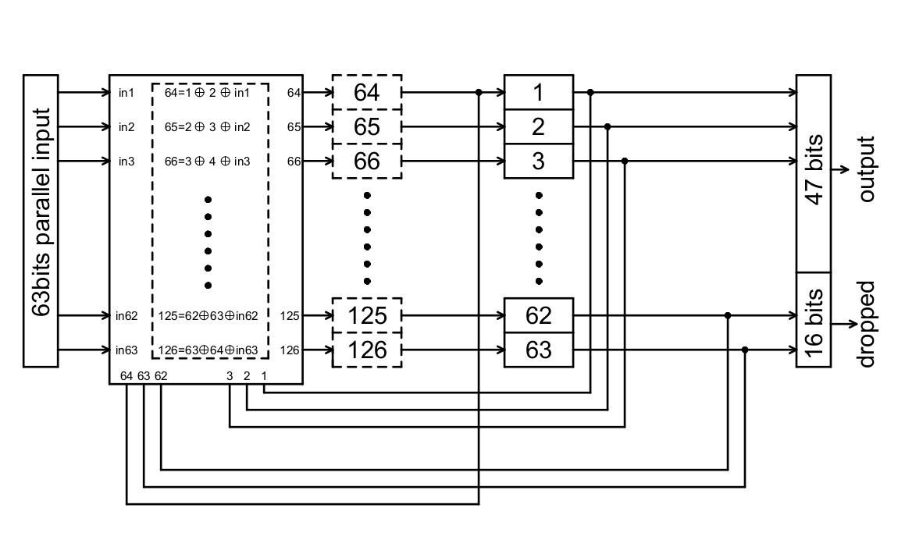
Fig 3. 63 bits parallel extractor. The input is grouped in 63 bits words.
An example of a 63-bit parallel extractor is shown in Fig. 3. The memory cells of the shift register are labeled from 1 to 126. The arrows indicate the shift of bits at each clock cycle. To generate an output of 63 bits in parallel, 126 registers are needed. Registers 1 to 63 store the state of the LFSR, and are to be sent to output at next clock cycle; registers 64 to 126 are used to store the next 63 bits that are newly generated by the XOR (Exclusive OR) operation.
Similar to the serial extractor, the operations in one clock cycle are as following:
1. 63 bits (a _{i}, i=1..63) are read from the physical randomness source.
2. Half of the register cells are updated with a combination of feedback signals obtained from a combination of stored bits and input bits, the other half is just a copy of a cell with a complex input:
Xi+63 = X_{i}  X_{i+1}  a_{i} and Xi = X_{i+63} for i = 1..63
This step will generate 63 new bits in registers i=64..126 in a single clock cycle. As before, a portion of the output needs to be discarded to ensure that the remaining bits contain enough entropy to form good numbers.
The parallel structured extractor will speed up processing speed at a cost of requiring more memory space and more XOR gates compare to its serial version. To build a parallel extractor using a n-bit LFSR that has k bit parallel output, k must be less or equal to n. The number of registers needed is simply n + k.
Performance
As a preliminary assessment, the 63-bit parallel extractor was used to process raw bits generated from a physical RNG (homodyne detection of vacuum field fluctuations). The output unbiased stream (50Gb) is sent through a randomness test suite. The processed stream passed the battery of tests of Randomness (http://www.stat.fsu.edu/pub/diehard/), no obvious bias and correlations were detected in the output stream (see below for the generated report from the test suite). Note that all the NIST tests are included in the “dieharder” test suite. A few tests indicate a weakness on this sequence, but passed the test for a different sample of 50Gb. This behaviour is not indicative of a problem with the random numbers but expected for any random number source.
The output of the test is shown below:
#=============================================================================#
# dieharder version 3.31.1 Copyright 2003 Robert G. Brown #
#=============================================================================#
rng_name |rands/second| Seed |
stdin_input_raw| 3.72e+05 |1517372462|
#=============================================================================#
test_name |ntup| tsamples |psamples| p-value |Assessment
#=============================================================================#
diehard_birthdays | 0| 100| 100|0.91515279| PASSED
diehard_operm5| 0| 1000000| 100|0.84850106| PASSED
diehard_rank_32x32| 0| 40000| 100|0.57685419| PASSED
diehard_rank_6x8| 0| 100000| 100|0.07080031| PASSED
diehard_bitstream| 0| 2097152| 100|0.31397394| PASSED
diehard_opso| 0| 2097152| 100|0.16289616| PASSED
diehard_oqso| 0| 2097152| 100|0.95205335| PASSED
diehard_dna| 0| 2097152| 100|0.39217429| PASSED
diehard_count_1s_str| 0| 256000| 100|0.13374594| PASSED
diehard_count_1s_byt| 0| 256000| 100|0.83574975| PASSED
diehard_parking_lot | 0| 12000| 100|0.96856245| PASSED
diehard_2dsphere| 2| 8000| 100|0.61058769| PASSED
diehard_3dsphere| 3| 4000| 100|0.93691086| PASSED
diehard_squeeze| 0| 100000| 100|0.49806865| PASSED
diehard_sums| 0| 100| 100|0.09967597| PASSED
diehard_runs| 0| 100000| 100|0.55234729| PASSED
diehard_runs| 0| 100000| 100|0.41180337| PASSED
diehard_craps| 0| 200000| 100|0.84628446| PASSED
diehard_craps| 0| 200000| 100|0.95319608| PASSED
marsaglia_tsang_gcd| 0| 10000000| 100|0.22374912| PASSED
marsaglia_tsang_gcd| 0| 10000000| 100|0.67270349| PASSED
sts_monobit| 1| 100000| 100|0.90577696| PASSED
sts_runs| 2| 100000| 100|0.61555205| PASSED
sts_serial| 1| 100000| 100|0.74779807| PASSED
sts_serial| 2| 100000| 100|0.79919104| PASSED
sts_serial| 3| 100000| 100|0.89508705| PASSED
sts_serial| 3| 100000| 100|0.95484472| PASSED
sts_serial| 4| 100000| 100|0.99314599| PASSED
sts_serial| 4| 100000| 100|0.99667529| WEAK
sts_serial| 5| 100000| 100|0.62591422| PASSED
sts_serial| 5| 100000| 100|0.47524360| PASSED
sts_serial| 6| 100000| 100|0.68114145| PASSED
sts_serial| 6| 100000| 100|0.97064317| PASSED
sts_serial| 7| 100000| 100|0.99441175| PASSED
sts_serial| 7| 100000| 100|0.25902990| PASSED
sts_serial| 8| 100000| 100|0.99981752| WEAK
sts_serial| 8| 100000| 100|0.79929453| PASSED
sts_serial| 9| 100000| 100|0.70162330| PASSED
sts_serial| 9| 100000| 100|0.99649280| WEAK
sts_serial| 10| 100000| 100|0.77717280| PASSED
sts_serial| 10| 100000| 100|0.95821058| PASSED
sts_serial| 11| 100000| 100|0.73268528| PASSED
sts_serial| 11| 100000| 100|0.70278710| PASSED
sts_serial| 12| 100000| 100|0.99976636| WEAK
sts_serial| 12| 100000| 100|0.92533496| PASSED
sts_serial| 13| 100000| 100|0.29124802| PASSED
sts_serial| 13| 100000| 100|0.66172969| PASSED
sts_serial| 14| 100000| 100|0.82336865| PASSED
sts_serial| 14| 100000| 100|0.90062024| PASSED
sts_serial| 15| 100000| 100|0.91630801| PASSED
sts_serial| 15| 100000| 100|0.50638259| PASSED
sts_serial| 16| 100000| 100|0.66897998| PASSED
sts_serial| 16| 100000| 100|0.48700297| PASSED
rgb_bitdist| 1| 100000| 100|0.90929700| PASSED
rgb_bitdist| 2| 100000| 100|0.83737882| PASSED
rgb_bitdist| 3| 100000| 100|0.07775290| PASSED
rgb_bitdist| 4| 100000| 100|0.83117357| PASSED
rgb_bitdist| 5| 100000| 100|0.65303631| PASSED
rgb_bitdist| 6| 100000| 100|0.60052964| PASSED
rgb_bitdist| 7| 100000| 100|0.84884908| PASSED
rgb_bitdist| 8| 100000| 100|0.06678232| PASSED
rgb_bitdist| 9| 100000| 100|0.14163757| PASSED
rgb_bitdist| 10| 100000| 100|0.35430293| PASSED
rgb_bitdist| 11| 100000| 100|0.52525078| PASSED
rgb_bitdist| 12| 100000| 100|0.49749634| PASSED
rgb_minimum_distance| 2| 10000| 1000|0.76635973| PASSED
rgb_minimum_distance| 3| 10000| 1000|0.80697509| PASSED
rgb_minimum_distance| 4| 10000| 1000|0.03904272| PASSED
rgb_minimum_distance| 5| 10000| 1000|0.43703643| PASSED
rgb_permutations| 2| 100000| 100|0.21048840| PASSED
rgb_permutations| 3| 100000| 100|0.35491364| PASSED
rgb_permutations| 4| 100000| 100|0.14894774| PASSED
rgb_permutations| 5| 100000| 100|0.80256430| PASSED
rgb_lagged_sum| 0| 1000000| 100|0.20585859| PASSED
rgb_lagged_sum| 1| 1000000| 100|0.30956399| PASSED
rgb_lagged_sum| 2| 1000000| 100|0.60223511| PASSED
rgb_lagged_sum| 3| 1000000| 100|0.96338489| PASSED
rgb_lagged_sum| 4| 1000000| 100|0.88077951| PASSED
rgb_lagged_sum| 5| 1000000| 100|0.85306279| PASSED
rgb_lagged_sum| 6| 1000000| 100|0.96905628| PASSED
rgb_lagged_sum| 7| 1000000| 100|0.55312091| PASSED
rgb_lagged_sum| 8| 1000000| 100|0.05473706| PASSED
rgb_lagged_sum| 9| 1000000| 100|0.99279613| PASSED
rgb_lagged_sum| 10| 1000000| 100|0.90280393| PASSED
rgb_lagged_sum| 11| 1000000| 100|0.19168593| PASSED
rgb_lagged_sum| 12| 1000000| 100|0.76622401| PASSED
rgb_lagged_sum| 13| 1000000| 100|0.21250463| PASSED
rgb_lagged_sum| 14| 1000000| 100|0.21421527| PASSED
rgb_lagged_sum| 15| 1000000| 100|0.15596677| PASSED
rgb_lagged_sum| 16| 1000000| 100|0.90897755| PASSED
rgb_lagged_sum| 17| 1000000| 100|0.52481370| PASSED
rgb_lagged_sum| 18| 1000000| 100|0.92209756| PASSED
rgb_lagged_sum| 19| 1000000| 100|0.90609529| PASSED
rgb_lagged_sum| 20| 1000000| 100|0.38819712| PASSED
rgb_lagged_sum| 21| 1000000| 100|0.96149941| PASSED
rgb_lagged_sum| 22| 1000000| 100|0.68838688| PASSED
rgb_lagged_sum| 23| 1000000| 100|0.31287396| PASSED
rgb_lagged_sum| 24| 1000000| 100|0.85048862| PASSED
rgb_lagged_sum| 25| 1000000| 100|0.94358319| PASSED
rgb_lagged_sum| 26| 1000000| 100|0.09055860| PASSED
rgb_lagged_sum| 27| 1000000| 100|0.86620426| PASSED
rgb_lagged_sum| 28| 1000000| 100|0.80300544| PASSED
rgb_lagged_sum| 29| 1000000| 100|0.53785935| PASSED
rgb_lagged_sum| 30| 1000000| 100|0.45516018| PASSED
rgb_lagged_sum| 31| 1000000| 100|0.98971731| PASSED
rgb_lagged_sum| 32| 1000000| 100|0.94109010| PASSED
rgb_kstest_test| 0| 10000| 1000|0.96114882| PASSED
dab_bytedistrib| 0| 51200000| 1|0.61645560| PASSED
dab_dct| 256| 50000| 1|0.32618066| PASSED
Preparing to run test 207. ntuple = 0
dab_filltree| 32| 15000000| 1|0.99846302| WEAK
dab_filltree| 32| 15000000| 1|0.23569882| PASSED
Preparing to run test 208. ntuple = 0
dab_filltree2| 0| 5000000| 1|0.70762665| PASSED
dab_filltree2| 1| 5000000| 1|0.45142406| PASSED
Preparing to run test 209. ntuple = 0
dab_monobit2| 12| 65000000| 1|0.86249128| PASSED

See Appendix 1.
This number can be found in the Grant’s Letter of Award. This number is NOT the WBS number
This number can be found in the Grant’s Letter of Award. This number is NOT the WBS number
This number can be found in the Grant’s Letter of Award. This number is NOT the WBS number
See Appendix 1
All official documents will be sent to the mailing address indicated. For income distribution, please keep us updated of any changes to your mailing address.
To fill out only if the inventive contribution is unequal among NUS inventors. If left blank, income (if any) will be distributed equally. The inventive contribution across NUS and non-NUS inventors should add up to 100%.
See Footnote 6.
To fill out only if the inventive contribution is unequal among non-NUS inventors. If left blank, income (if any) will be distributed equally. The inventive contribution across NUS and non-NUS inventors should add up to 100%.
See Appendix 2.
See Appendix 3.

